**SMITHYCROFT SECONDARY SCHOOL**



**TRANSITION INFORMATION BOOKLET 2020**

# A Message from the Headteacher

We currently find ourselves in strange and uncertain times because of the Covid 19 virus outbreak.

Despite this, we are working very closely with our primary school colleagues to ensure that every young person’s transition from primary to secondary school will be as successful and supportive as we can possibly make it.

Prior to the current situation, a great deal of work had already been carried out surrounding transition and, in normal circumstances, there would have been a number of further events and initiatives taking place in the upcoming weeks. All of these were aimed at developing as much knowledge about each young person and affording them as positive an experience as possible of the school before formally joining us for the new academic year.

Most of these events or initiatives have taken place or are continuing to do so as colleagues work remotely. Our transition programme has so far included:

* An Open Evening in September 2019
* An Induction Visit in October 2019
* Sports Leaders sessions
* Some extra subject taster visits after school
* Some Pupil Interviews with Head of S1 and Pastoral Care

Meetings with P7 Teachers and Primary Head Teachers are currently taking place remotely. Enhanced Transition meetings have been going on throughout the year and continue to take place remotely.

In relation to the Induction Days and Open Afternoon scheduled for May, we will make sure that we put arrangements in place so that these events take place in some capacity when it is safe to do so.

As you can see, we have already embarked on our transition programme and will continue to strive to deliver a transition experience which provides your childwith as full and well-rounded an experience, at the heart of which is a smooth transition from primary to secondary school, as we possibly can at this current time.

Over the coming months**,** if there are any questions, issues or concerns that you have please send these to the Smithycroft Headteachers e-mail address and we will respond to you.

I know that these are uncertain times and we are unclear what returning to school will look like. I am looking forward, however, to meeting you and your child when it is safe for us to return and I hope that your young person is excited about joining us in our brilliant school.



Patrick Oberg

Headteacher

# Senior Leadership Team

**Head Teacher:** Patrick Oberg

**S1/2 Year Head:** Adrian Hood

**S2/3 Year Head:** Matt Hodgman

**S4/5/6 Year Head:** Marie Kerr

# School Day



When does school start and finish on a **Tuesday, Wednesday and Friday**?

**Start:** 8.50am **Finish:** 3.00pm

When does school start and finish on a **Monday and Thursday?**

**Start:** 8.50am **Finish:** 3.50pm

# S1 Curriculum

What’s in the Smithycroft Broad General Education and how many times a week will S1 visit each subject?

|  |  |
| --- | --- |
| **Subject** | **Number of Periods** |
| Registration | Every morning |
| **Languages** | |
| English | 4 periods |
| French | 3 periods |
| **Mathematics** | |
| Maths | 4 periods |
| **Social Studies** | |
| Social Subjects | 3 periods |
| *(History, Modern Studies, Geography)* | |
| **Religious and Moral Education** | |
| RMPS | 2 periods |







|  |  |
| --- | --- |
| **Subject** | **Number of Periods** |
| **Sciences** | |
| Science | 3 periods |
| **Health and Wellbeing** | |
| PE | 2 periods |
| PSE | 1 period |
| Home Economics | 2 periods |
| **Technologies** | |
| Technical | 2 periods |
| ICT | 1 period |
| **Expressive Arts** | |
| Music | 2 periods |
| Art | 2 periods |
| **Other** | |
| Elective | 1 period |

**

**

# Interval and Lunchtime

|  |  |  |
| --- | --- | --- |
|  | **Interval** | **Lunchtime** |
| **Where can they go?** | All pupils **stay within school grounds** during this time. | S1 pupils will **remain in** **school for lunch until the September Weekend.**  A decision will then be made about going out-with school based on the responsibility levels of each pupil. |
| **What is available to eat and drink?** | A range of food and drink can be purchased from the canteen **using money or a Q card.**  **Available food and drinks include:**  Hot rolls, toast, toast and cheese, cold rolls, muffins, cookies, water, milk, fruit juice, hot chocolate and tea. | Pupils can bring a **packed lunch** or can **purchase a school meal** for £1.90 from the Fuel Zone.  **Available food and drinks include:**  Hot meals, rolls, baguettes, salad bar, soup, sandwiches, crisps, muffins, biscuits and a range of drinks. |

Pupil Attendance

**How is attendance monitored?**

There is a period-by-period marking of attendance.

We are very fortunate to have our own Home School Support Worker who monitors attendance and timekeeping very closely with Pastoral Care staff.



What do I do if my child is unable to attend school due to illness?  
  
Please contact the attendance line on: **0141 287 0039**.

**What happens if my child is sick or injured in school?**

Pupils will come to the school office and, if appropriate, are then referred to their Year Head.

A First Aider and the parent is called if necessary.

**How is my child’s progress monitored?**

**Tracking and monitoring**: Regular updates will be sent home from departments regarding the progress of each pupil. A leaflet with more information will be issued to pupils at the start of the year.



**Homework**

Pupils will be issued with regular homework tasks from each subject through the Show My Homework app.

What is the mobile phone policy?  
  
Pupils are responsible for their own belongings in school. Pupils will **not be permitted** to use their mobile phone in the classrooms or corridors.



# 

**How do pupils enter and leave the school?**

All pupils are permitted to enter the school by the front entrance. S1-3 will use the side entrance to leave at lunchtime and the end of the school day. S4-6 may use the front or side entrance to leave the school.

House System

There are 4 different House Groups in the school:

|  |  |  |  |
| --- | --- | --- | --- |
| **Barbour House**  **(Red)** | **Logie Baird House**  **(Blue)** | **Inglis House**  **(Yellow)** | **McIntosh House**  **(Green)** |
| 1.1 | 1.2 | 1.3 | 1.4 |
| Pupils in 1.5 will be placed in either Barbour or Logie Baird House and pupils in 1.6 will be placed in either Inglis or Mackintosh. | | | |

* We aim to place pupils in the same House as their **siblings**.
* All S1 pupils must purchase their **House t-shirt** for wearing at P.E. and House events.
* Pupils will complete **S1 PSE lessons** with their allocated Pastoral Care teacher.

Extra-Curricular Activities

There is a vast range of clubs available to all pupils in the school.

**These include:**

Chess Club Art Club Cooking Club Gymnastics Football Dance Volleyball Guitar Musical Theatre S1 Choir Keyboard Percussion

Basketball Rugby Craft Club Badminton Bridgeton Burns Singing LGBTQ

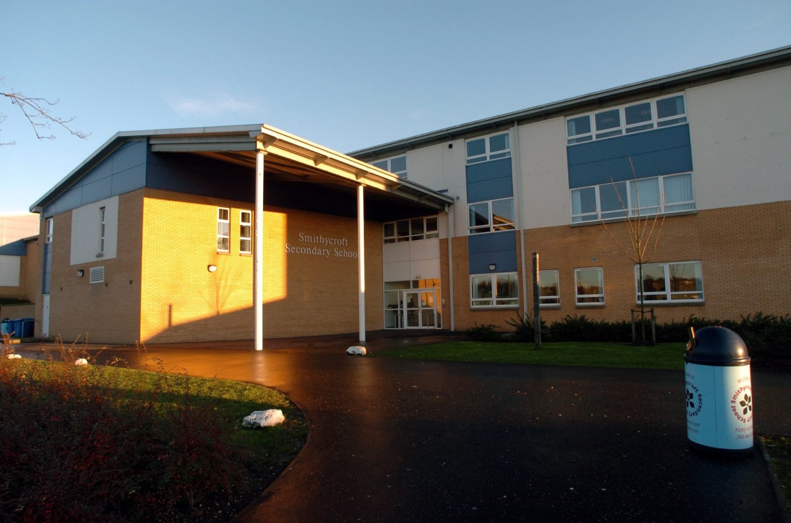**The School Building**

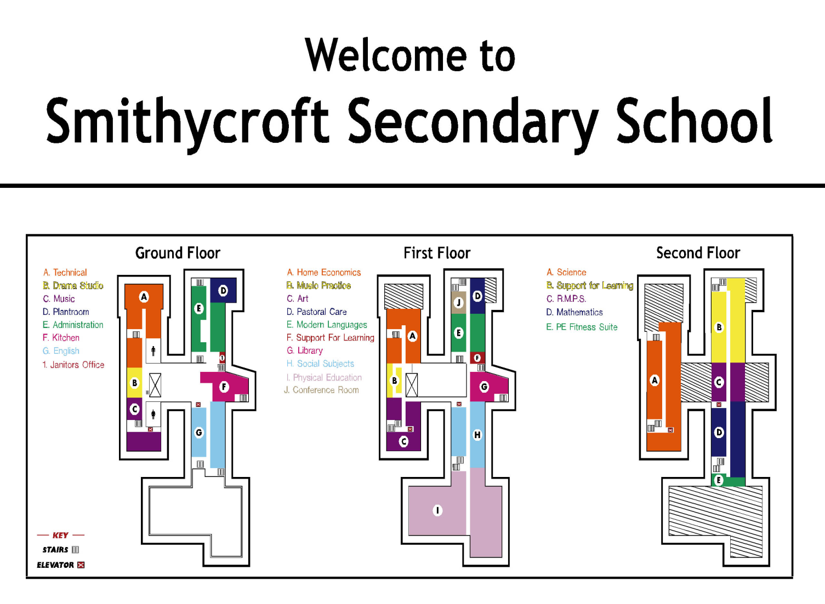

**Getting Around The School Building**

TECHNICAL

MUSIC

STREET AREA

GROUND FLOOR

ENGLISH & DRAMA

FUEL ZONE

OFFICE

FRONT DOOR

HEALTH AND FOOD TECHNOLOGY

ART

STREET AREA

FIRST FLOOR

HISTORY &

MODERN STUDIES

PASTORAL CARE

PE

SFL

LIBRARY

FRENCH

FRONT DOOR

SCIENCE – BIOLOGY, PHYSICS & CHEMISTRY

SECOND FLOOR

STREET AREA

MATHS

RMPS

ICT

BUSINESS

FRONT DOOR

**Uniform**

* Full uniform must always be worn.
* A jacket can be worn over the blazer; however it must be removed while inside the school building.

Girls;

* Blazer
* School tie
* School Hoodie or Zoodie
* School jumper or plain black jumper
* Blouse
* Black trousers or skirt
* Black trainers or shoes.

Boys;

* Blazer
* School tie
* Shirt
* School Hoodie or Zoodie
* School jumper or plain black jumper
* Black trousers
* Black trainers or shoes

**Physical Education**

**Important information**

**Extra-curricular Clubs:**

There is a vast number of extra-curricular clubs running during lunchtimes and every night after school. It would be great if you could get involved in as many as possible.

**Valuables:**

We ask that you do not take valuable items or large quantities of money to school on days that you have PE. The changing rooms will be locked but the school does not take responsibility for the loss or damage to any items whilst in the Physical Education Department.

**Jewellery & Piercings:**

The department must adhere to the following official Glasgow City Council guidelines.

“The Health and Safety document reads: PE  Safety File: Pg. 7  Point: 2.7 Personal effects (e.g. jewellery, body piercings, items of religious significance, watches, hair slides and belts constitute a hazard and may cause injury if worn whist participating in Physical Education and **must be removed**.”

We ask you to remove ALL piercings before taking part in Physical Education. Taping them up is not acceptable and if you do not remove piercings you will not be able to participate in the practical part of your PE lessons. This will be noted in your school records.

**If pupils are planning getting a piercing can we ask that it is done at a safe time which will not impact on their participation in PE.**

**PE KIT;**

**Indoor:** Houset-shirt, shorts, leggings, tracksuit bottoms and trainers.

**Outdoor:** House t-shirt, hooded top, tracksuit top, zipper, sweatshirt, rain jacket (not worn to school), shorts, leggings, tracksuit bottoms, trainers or football boots.

No football tops or clothing with offensive slogans are allowed.

House T-shirts (2 styles) are £10 for XS and S and £11 for M,L and XL. Order forms can be collected from the school office. These T-shirts are compulsory.

Long hair must be tied back for health and safety reasons.

**Timetable**

* Monday and Thursday are the longer days at school.
* Before school, during break and lunch, are toilet times.
* Arriving to registration class**,** after 8.55am**,** will result in you being marked as late.
* You must go straight to class and ask the teacher’s permission before leaving class.

|  |  |  |  |  |
| --- | --- | --- | --- | --- |
| Monday | Tuesday | Wednesday | Thursday | Friday |
| Registration  8.50-9.00 | Registration  8.50-9.00 | Registration  8.50-9.00 | Registration  8.50-9.00 | Registration  8.50-9.00 |
| Period 1  9.00-9.50 | Period 1  9.00-9.50 | Period 1  9.00-9.50 | Period 1  9.00-9.50 | Period 1  9.00-9.50 |
| Period 2  9.50-10.40 | Period 2  9.50-10.40 | Period 2  9.50-10.40 | Period 2  9.50-10.40 | Period 2  9.50-10.40 |
| Break  10.40-10.55 | Break  10.40-10.55 | Break  10.40-10.55 | Break  10.40-10.55 | Break  10.40-10.55 |
| Period 3  10.55-11.40 | Period 3  10.55-11.40 | Period 3  10.55-11.40 | Period 3  10.55-11.40 | Period 3  10.55-11.40 |
| Period 4  11.40-12.35 | Period 4  11.40-12.35 | Period 4  11.40-12.35 | Period 4  11.40-12.35 | Period 4  11.40-12.35 |
| Period 5  12.35-1.25 | Lunch  12.35-1.25 | Lunch  12.35-1.25 | Period 5  12.35-1.25 | Lunch  12.35-1.25 |
| Lunch  1.25-2.10 | Period 5  1.25-2.10 | Period 5  1.25-2.10 | Lunch  1.25-2.10 | Period 5  1.25-2.10 |
| Period 6  2.10-3.00 | Period 6  2.10-3.00 | Period 6  2.10-3.00 | Period 6  2.10-3.00 | Period 6  2.10-3.00 |
| Period 7  3.00-3.50 |  |  | Period 7  3.00-3.50 |  |

**Smithycroft Charter**

The Smithycroft Charter explains the positive ways to conduct yourself both in school and in the wider community.

Meeting these targets will increase the chances of you attending trips and reward days.

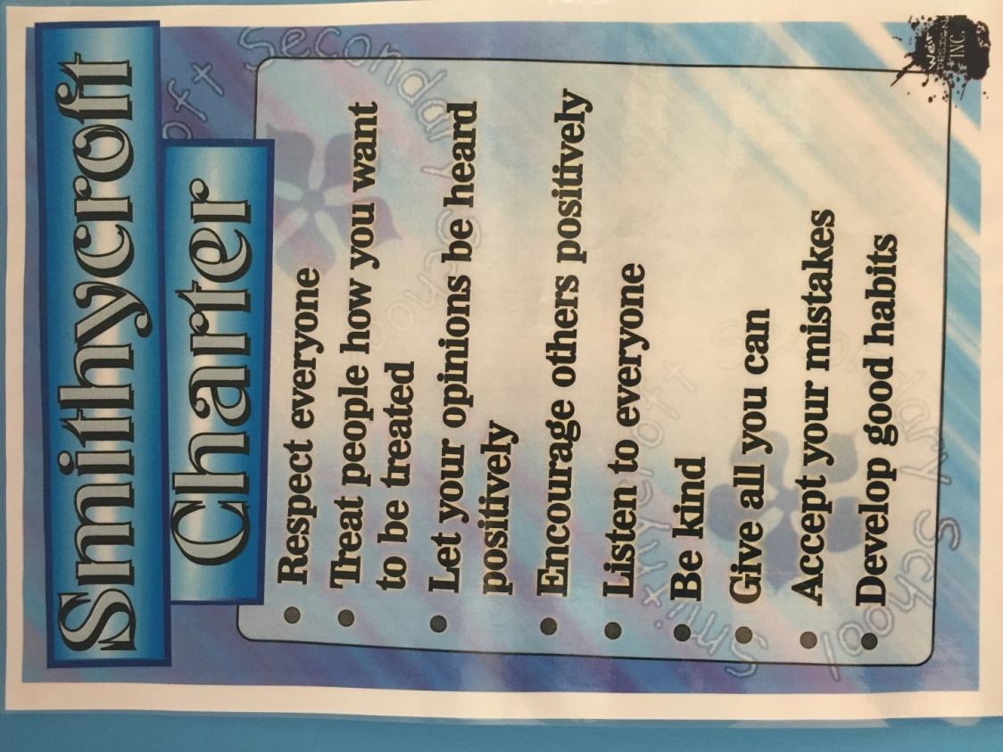

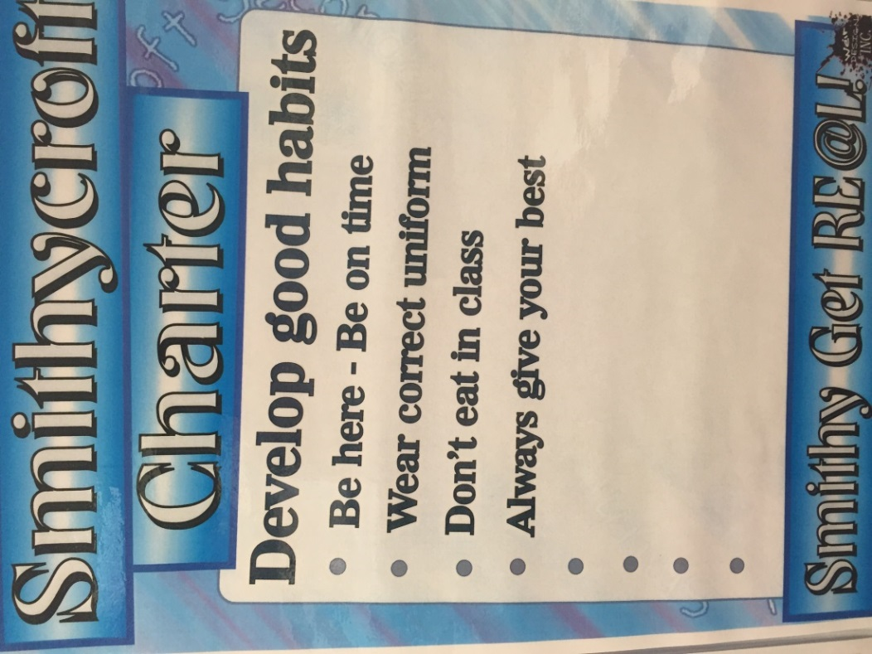

**KEY PEOPLE**

  

Head Teacher – Mr Oberg PT SFL Ms Stobie Head of S1 – Mr Hood



Home School Support Worker- Mr Jakeway



1.1 – PT Pastoral Care Mrs Wilson



1.2 – PT Pastoral Care Mrs Asher



1.3 – PT Pastoral Care Mr Brown



1.4 – PT Pastoral Care Mrs Hughes



1.5 & 1.6 – PT Pastoral Care Mr Murphy

**Support For Learning**

All children receive help with their learning and some might need more help than others. A child or young person is said to have “additional support needs” if they need more, or different, support from what is normally provided in schools for children of the same age.

A child or young person may have additional support needs for lots of reasons including:

* A physical disability
* Being a young carer
* Changing schools a lot
* Being bullied
* Having a communication difficulty
* Being looked after by the local authority
* Having a long term illness
* Having a specific learning difficulty such as Dyslexia
* Having an Autistic Spectrum Disorder

In Smithycroft Secondary, we want all of our young people to meet their full potential and the Support for Learning Department has a crucial role to ensure that barriers to learning are overcome. We provide young people with the support they need, working very closely with parents and external agencies in order to set and meet individual learning targets. Interventions may include one or more of the following:

* In-class support
* Individual or small group withdrawal for literacy and numeracy support
* Specialist literacy support for Dyslexic and EAL learners
* Small group withdrawal for bespoke social communications skills training
* Time-out facility to meet sensory needs
* Individual mentoring using the Nurturing Principles to support social and emotional behavioural needs
* Support during interval/lunchtime within group room for those who prefer a quieter, more supported environment.
* Advising staff on strategies to support leaning and behavioural needs within the classroom

**Smithycroft Secondary Uniform Information Sheet - New S1**

**Our Compulsory Uniform:**

Blazer £34.00 / £40.00

Tie £4.00

White school shirt

Black shoes (all black with no colour whatsoever)

Black trousers or black skirt of an appropriate length

**Compulsory PE Kit**

PE Top (house colour) £10.00 / £11.00

Black shorts, jogging trousers or leggings

**Optional:**

Smithycroft Knitwear with logo – Jumper £17.00 / £18.00

Tank Top £14.00 / £15.00

Cardigan £18.00 / £19.00

Smithycroft PE leggings with logo £17.00

Smithycroft Hoodie £16.50

Smithycroft Zoodie £18.50

**Blazers:**

Usually our blazer supplier would come into Smithycroft Secondary during the Primary Induction Day’s to measure pupils for their blazers. Pupils would then been issued with an order form with their required size written on it.

Unfortunately**,** this will not be possible at the current time and we will wait until it is safe to put in arrangements for this process to be undertaken prior to your young person joining the school.

**PE Tops:**

Smithycroft PE tops are compulsory and should be ordered at the same time as other items of uniform - once it is safe to do so.

**Hoodies / Zoodies**

Following consultation with pupils, parents and staff we introduced Hoodies and Zoodies to the uniform. These items are not compulsory and, if purchased, should be worn under the blazer. All of the hoodies and zoodies (full zip with hood) come in black and will have the school badge on them the same as with the blazer. These are not a replacement for our blazers which remain a compulsory part of the uniform.

**Knitwear:**

Smithycroft knitwear has to be paid for before we can order it. Again,we will let you know how we are going to organise the process for ordering all items when we are advised by the government.

**Ties:**

We keep a stock of ties in school and they can be purchased when it is safe to do so.

**FREQUENTLY ASKED QUESTIONS**

Hopefully the booklet will already have answered a lot of the questions and queries you have. Here are answers to a few questions that a number of people have asked.

If you have any further queries please send them to this e-mail address: [Headteacher@smithycroft-sec.glasgow.sch.uk](mailto:Headteacher@smithycroft-sec.glasgow.sch.uk)

We will be in touch as soon as we have any further information regarding the Transition process.

1. How are we going to order blazers, school jumpers etc. if the lockdown continues?

**Usually pupils would be measured up for their blazers by our uniform suppliers on their induction days in May. Order forms are then issued and completed by parents/carers. Payments can be made at the school office prior to collecting any uniform purchased.**

**It is hoped that we will be able to set up a similar process when it is safe to do so and arrangements for taking payments will be made.**

1. How will Smithycroft ensure that P7 children are supported with no transition activities and minimal schooling in Term 4?

**A number of elements of our Transition process had already taken place prior to the school closures. We are currently liaising with our Primary colleagues to gain as much information on every young person due to join us in the new academic year, which will begin when it is safe to do so. This information will be used to best support the young people when they join us.**

**Enhanced Transition is being worked on by Ms Stobie, our PT Support for Learning, and she will be contacting parents/carers throughout this process.**

**Primary schools are working incredibly hard to support young people with their learning at this challenging time in order to minimise the impact on their progress before moving to Secondary School. Pupils requiring any additional support when they join us at Smithycroft will receive this from our excellent Support for Learning Department.**

1. Does Smithycroft run something similar to a buddy system?

**We do have a buddy system within the school where all S1 pupils will be paired up with a senior pupil. We find this has a very positive impact on making young people feel welcome and supported within the school.**

1. Who will pupils share any worries/ concerns with while at school?

**Every young person will have a Pastoral Care teacher who they can go to if they have any worries or concerns they feel they need to talk about. All our colleagues in Smithycroft are approachable and supportive of our young people and will listen to them if they have an issue, but may have to pass it onto their Pastoral Care teacher if they do not feel they are in the position to help their situation.**

1. What is the Smithycroft behaviour system like?

**Smithycroft is a nurturing school and believes very much in developing positive relationships which lead to the promotion of positive behaviour in school. We ask our young people to try to follow the Smithycroft Charter and take ownership of their own conduct trying to be respectful and kind to others.**

1. What will happen to help the young people feel confident on the first day bearing in mind they did not receive the opportunity to visit the school?

**Usually young people would have had their induction days in May which would have helped them become more confident about joining us at Smithycroft. They would be in their new classes and be given the opportunity to meet their new classmates, teachers and support staff.**

**We will try and set up an opportunity for the young people and parents/carers to visit the school prior to the school year beginning, whenever that will be. This will be as close to the experience they would have had in May as we can make it.**

**In relation to the first day we cannot confirm how that will look at the moment as we will need to wait for advice from the government in relation to returning to school safely.**

1. What classes will children be in?

**We are currently still gathering information on all the young people who will be joining us. Once this information gathering is complete we will start to populate classes.**

**Your primary school should have been in touch to ask if you have any preferences in relation to who you would like to be in the same class as. We can’t promise that you will be in the same class as all your friends but we will try to make sure you are in with at least one friend requested from your primary school.**

**Please contact your primary school if you haven’t already given this information to your teacher.**

1. What if I get lost?

**This is a very common question and the first thing I will say is, don’t panic. The school is much bigger than you will be used to but you will get used to your new surroundings very quickly.**

**Every class will have some S3 student guides who will take you from class to class for the first few days. This will help build your confidence moving around the school.**

**There is a map in this booklet for you to have a look at. If you do get lost ask somebody to point you in the right direction, the school is full of people who are welcoming and will help you.**

1. Free school meals - do we get a ticket from our teacher like in primary?

**All young people at Smithycroft Secondary School are issued with a Q card for use in the school canteen. If you are entitled to free school meals, money will be credited automatically to your Q card every day.**