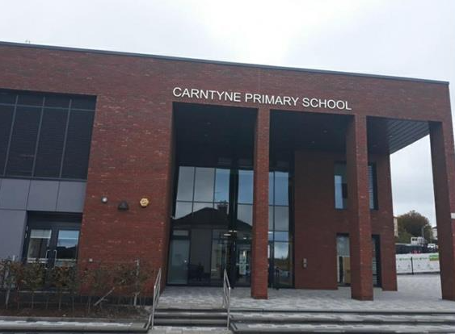

Handbook

2025/26

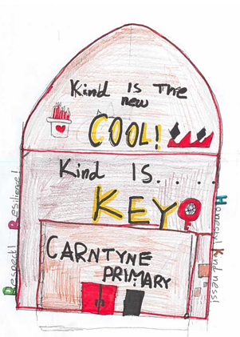
Picture by Amelia McK P5 1
Picture by Amelia McK P5 2


Welcome to Carntyne Primary School


We are happy to welcome you and your child to our school. We hope that your child’s time at Carntyne Primary will be a happy and rewarding experience.

This handbook is your first introduction to Carntyne Primary School. It provides general information about our school and we hope this will be helpful to you.

We are always ready to discuss any enquiries about our school.

We look forward to working with you to ensure that your child becomes a successful learner, a confident individual, a responsible citizen and an effective contributor at Carntyne Primary School.

- Mrs Jo Church
Headteacher

School Vision & Values

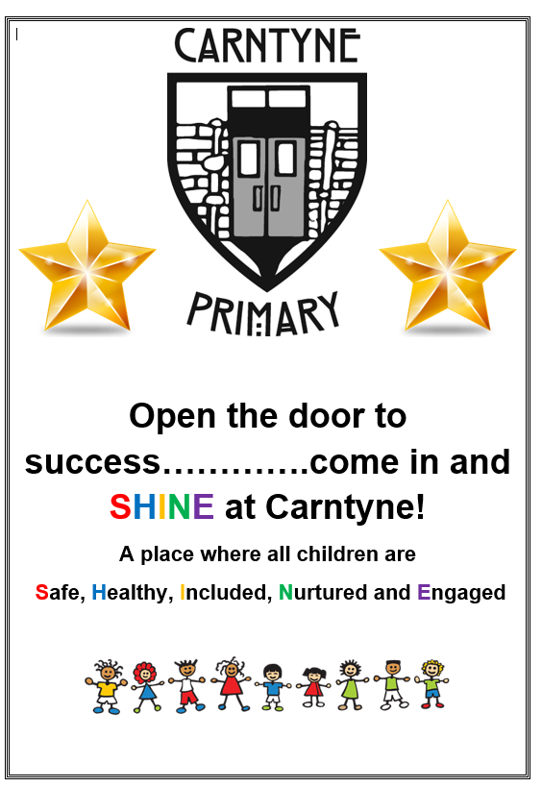

We promote the development of our young people as successful learners, confident individuals, responsible citizens and effective contributors and believe our vision, values and aims should reflect the principles outlined in Glasgow City Council’s “Children’s Charter for Young People” and UNICEF’s rights and responsibilities for all children. Our revised core school values were officially launched in 19/20. They are as follows:

- Respect
- Honesty
- Inclusion
- Kindness
- Resilience

School Aims
We want our learners to
• be able to read, write, be numerate and knowledgeable and to understand how to gain knowledge for themselves from the environment and world around them.
• have confidence and independence as learners to think for themselves
• have highly developed skills in emotional literacy, social communication skills, thinking and problem-solving capacity
• have knowledge of the world around them, and a sense of self and place in order that they develop as engaged citizens
• develop understanding of how to risk assess and think for themselves in a way that helps them make sense of a rapidly changing world
• value each other and act in a responsible and ethical way

School Information
Carntyne Primary School
39 Redford Street
Glasgow
G33 2HE
Phone 0141 770 4305
Email headteacher@carntyne-pri.glasgow.sch.uk
School Website http://www.carntyne-pri.glasgow.sch.uk/

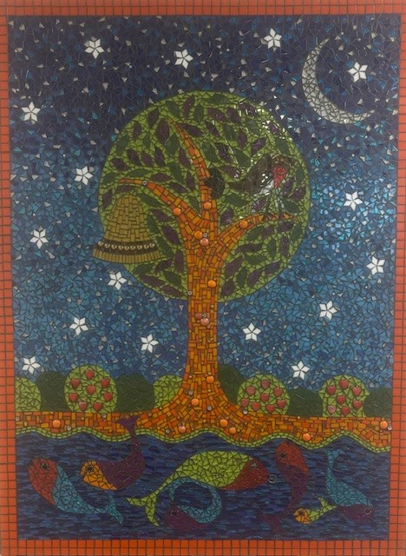
Background Information
- Co-educational school
- Non-Denominational
- Stages taught: P1 –P7
- Current Roll: 329

Our current school was formally
opened by Councillor Chris
Cunningham on 20th September 2019.

School Staff
A full list is available on the school website and parents will be updated on any changes as required.
The leadership team is as follows:

- Headteacher Mrs J Church



- Depute Head Teacher Mrs N Aujla



- Principal Teacher (P1 - P3) Mrs P Dolan



- Acting Principal Teacher (P4 -P5) Mrs S Timoney


- Principal Teacher (P4 - P7) Ms E Farquharson

Enrolment
Registration of Primary 1 children takes place in November and is advertised widely in local press etc. Prospective parents are welcome to visit the school and should contact the school office. Enrolment is now conducted online – see link below.

Families living outwith the catchment area are welcome to make a placing request to attend a Glasgow Primary School but must enrol their child online as a first step.

Further information is available using the following link: https://www.glasgow.gov.uk/Enrolment

Organisation of Classes
The following guidelines set by Scottish Government apply.
P1 maximum 25
P2 & 3 maximum 30
P4 – 7 maximum 33
Composite classes maximum 25
Composite classes have pupils from more than one stage.

School Hours
School opens 9.00am
Morning Break 10.30 – 10.45am
Lunch 12.15 – 1.00pm (P1 12.00pm-1.00pm)
Dismissal P1 - 2.55pm
P3 –P7 - 3.00pm
Should you need to collect your child early or to attend an appointment please let us know in advance by emailing headteacher@carntyne-pri.glasgow.sch.uk.

School Term Dates
Details of school holidays are available on the Glasgow City Council website:
https://www.glasgow.gov.uk/article/4276/School-Term-Dates

Keeping up-to-date

Our School App is our main source of communication and a great deal of information is issued from the app. Please download the School App for Parents from the app store.

We also have the facility to send emails and text messages to parental contacts. It is very important that you ensure this your mobile phone number and email is kept up-to-date. In the event of the school being closed due to an emergency you will be contacted by text.

Parents Pay is used to order and pay for school meals. It can also be used to pay for clubs, trips and any other things that require payment.

Parents Portal is another app which is used to link with families. This is linked to your MyGovScot account. This allows you to update contact details, access consent forms and book Parents’ evening appointments.

Pupil Absence
Within Glasgow Primary School good attendance is encouraged at all times and children rewarded accordingly. Parents are asked to advise if their child is going to be absent. This should be done as early as possible on the first day of absence. If your child is going to be absent for some time, it would be helpful to know at the earliest opportunity. The school uses daily text messaging to inform Parents and Carers of absence if no contact is made. All unexplained absence is investigated by the school and appropriate action taken. All calls must be made to the Pupil Absence Reporting Line on 0141 287 0039. The line is open between 08.00 – 15.30 Monday to Friday.

Alternatively you can use the online form on the Glasgow City Council website:
https://www.glasgow.gov.uk/article/4277/Pupil-Absence-Reporting

The teachers take a register at 9.00am. If your child arrives shortly after 9.00am they should come through the main door and report to the main office where they will be marked late.

Enrolment & Transition to Secondary School

Enrolment
Registration of Primary 1 children takes place in November and is advertised widely in local press etc. Enrolment is now conducted online – see the link below.

Families living outwith the catchment area are welcome to make a placing request to attend Glasgow Primary School but must enrol their child online as a first step. Further information is available using the following :
https://www.glasgow.gov.uk/article/4275/Starting-Primary-School

Transfer to Secondary School
Children and young people normally transfer between the ages of 11 ½ and 12 ½, so that they will have the opportunity to complete at least 4 years of secondary education. Parents and carers will be informed of the school arrangements no later than December of P7. Children from our school normally transfer to Smithycroft Secondary School.

A two-day visit is scheduled for June of each year. Pupils who need additional support can join the enhanced transition programme

The contact details for Smithycroft Secondary are:
Mr Patrick Oberg: Head Teacher
Smithycroft Secondary School
282 Smithycroft Road
G33 2QU
0141 582 0220
http://www.smithycroft-sec.glasgow.sch.uk/
Medical & Healthcare
The school nurse visits at various times during the year for routine health checks, vaccinations and medical examinations. Parents are kept informed by letter.

If a child becomes ill during the course of the school day, he/she may require to be sent home. Please ensure that you keep the school informed of all contact details.

Parents should inform the school of any medical requirements relating to their child. If a child requires medication during the school day, parents must complete the appropriate medical form. This is available on request from the school office.

If your child has a medical need

It is particularly important that the school be informed of any child who may have particular medical requirements.

Pupils who require long term medication are able to keep this medication in school. Their parent/carer must visit the main office and complete a parental agreement form and individual health care plan, giving permission for medication to be stored and administered in school.

Playground First Aid
These will be dealt with promptly and professionally by our first aiders. We will only contact you if we feel your child may require further care. Your child may come home with a slip advising your child has received first aidduring the day.

Feeling unwell
If your child is unwell and we feel that they are unfit to continue with their day at school we will contact you to make arrangements for them to be collected.

Emergencies
We make every effort to maintain a full educational service, but on occasion circumstances arise which lead to disruption. Schools may be affected by, for example, severe weather, temporary interruption of transport, power failures or difficulties of fuel supply.

In such cases, we shall do all we can to let you know about the details of our closure or re-opening by using texts, email, on our Parent apps and X (formerly Twitter).

School Uniform
The school uniform is:

- Red Sweatshirt/Jumper Cardigan
- White Shirt/Polo Shirt
- School Tie
- Grey/Black Trousers
- Grey/Black Skirt/Pinafore


Our supplier of school uniform is BE Schoolwear. They stock a supply of sweatshirts, cardigans, polo shirts, ties, bags and scrunchies. It is expected that all children attending Carntyne Primary School will adhere to this dress code.

BE Schoolwear
35 Argyle Street
GLASGOW
G2 8AH

Phone: 0141 221 4472
Website: https://www.border-embroideries.co.uk/

PLEASE LABEL ALL CLOTHING CLEARLY WITH YOUR CHILD’S NAME. ALL LOST PROPERTY WILL BE DONATED TO THE UNIFORM BANK AT THE END OF EACH TERM

P.E. Kit

It is important that pupils come prepared to learn and for PE this requires appropriate clothing. All jewellery should be removed. Pupils who are not participating in PE must have a note or medical certificate. Pupils who are unable to participate in practical PE should still bring their kit to allow them to assist in the lesson by refereeing, keeping scores or assisting with the distribution of equipment. This ensures that they are still able to take part in some way in the work of the class and do not miss out on the knowledge and understanding of the course.

It is essential that all children have a change of shoes for P.E. during the winter months.

There are forms of dress that are unacceptable in school, such as items of clothing which:

- Potentially encourage factions (such as football colours)
- Could cause offence (such as anti-religious symbolism or political slogans)
- Could cause health and safety difficulties (such as loose-fitting clothing, jewellery)
- Could cause damage to flooring
- Carry advertising particularly for alcohol or tobacco
- Could be used to inflict damage on other pupils

Clothing & Footwear Grants
For information and application forms regarding Clothing Grants and Footwear Grants please use the following link https://www.glasgow.gov.uk/article/2492/Clothing-Grants-Free-School-Meals
All children in P1-P6 are entitled to free school meal, however, to access free breakfast club and for the school to access Pupil Equity Funds for our students it is imperative that all Parents apply for Clothing Grant/Free School Meals if entitled to them.

School Meals
Our school provides a lunch service which offers a variety of meals and snacks.
Medical diets for children can be provided, please inform the Head Teacher.
Further information and menus can be found here:
https://www.glasgow.gov.uk/article/6188/Fuel-Zone-School-Meals

Children who prefer to bring packed lunches will be accommodated in a suitable area.

All P1–P6 children are entitled to a free school meal.

The current cost of school meals for P7 children is £1.90

If you plan to send your child/children to breakfast club, you should inform the staff of any medical dietary requirements.

Information and application forms for free school meals may be obtained at https://www.glasgow.gov.uk/index.aspx?articleid=17885

Breakfast Club
This service is run by Glasgow City Council and is available in the dining hall from 8.00am to 8.45a.m. The service runs Monday to Friday. The children are supervised when they are inside the dining hall by employees of Glasgow City Council. The cost is £2.00 per day and £1.00 for each additional child per family and is payable via ParentPay. Children who qualify for free school meals are exempt from paying for breakfast club so it is important to apply even if your child gets a free school lunch due to their age.

After School Facility
There is an After School Care facility available from 3.00pm – 6.00pm at Carntyne Primary School. This is run by Connect 2.

They can be contacted by telephone on - 0141 551 8425

If you wish to enquire about spaces available, then please contact the above number and the staff will be happy to help you.

Transport
There is an obligation on local authorities to provide school transport assistance for children and young people who are entitled. Transport is not provided to take a child home at lunchtime. Strathclyde Partnership for Transport (SPT) arrange transport for mainstream primary and secondary children on behalf of Glasgow City Council. More information can be found at: https://www.glasgow.gov.uk/article/5505/School-Travel-Assistance

Learning Community
Carntyne Primary School is part of a Learning Community. Our Learning Community is called Smithycroft Learning Community and it comprises the local non-denominational pre-5 and primary schools as well as Smithycroft Secondary.

We also work alongside various local community organisations including With Kids, Quarriers, SOS (Sense over Sectarianism), Junction 12 and PEEK. They provide the children with support and various activities including sports and games within the school environment.

Communication with Parents
At Carntyne Primary School we use a variety of ways to keep in touch.

Open Door Policy – the senior leadership team aim to be available for all parents and carers at any time providing they are not teaching or in another meeting. Please scan the QR code below to request a call/meeting with the relevant member of staff.
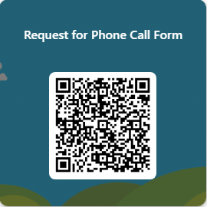

Newsletters – will be sent out on a regular basis to keep parents informed about the work of the school.

Letters – further information which requires a response may be out in letter form or via email.

School website/Twitter/App – will contain a great deal of information about the school. It is a good idea to check this regularly.

Text messaging – You may also receive text reminders about events/school closures etc.

Meetings – Parents and carers are welcome in the school to discuss any aspect of their child’s development and progress. To avoid disappointment, it is advisable to make an appointment. There are various opportunities throughout the year when parents can discuss their child’s progress with the class teacher and view the child’s work.

Parents and carers are welcome at other events throughout the school year e.g. workshops, information evenings, class performances, religious and other assemblies. The school newsletter and website will keep you informed.

Emergency Contact information

At the start of each school session, parents will be issued with the annual data check. Please ensure that this is completed and returned to the school. It is also important that you let us know if there are changes to your telephone number(s) or to those of your emergency contacts throughout the year.

Data Protection – use of information about children and parents/carers

We collect information about children attending school (and also about parents/carers, emergency contacts etc. provided in the annual data check) to allow us to carry out the Council’s functions as the education authority for the City of Glasgow. This may sometimes involve releasing personal information to other agencies and other parts of the Council, particularly in relation to child protection issues or criminal investigations, and it may also be used for research purposes (see the link below for more details regarding this).

Information held by the school is, in legal terms, processed by Glasgow City Council. The Council is registered as a data controller under the Data Protection Act 2018 and all personal data is treated as confidential and used only in accordance with the Data Protection, the General Data Protection Regulations, and the Information Use and Privacy Policy approved by the City Council. For more information on how we use personal information, or to see a copy of the Information Use and Privacy Policy, see https://www.glasgow.gov.uk/article/1169/Glasgow-City-Council-Statement-on-GDPR-Compliance

Education specific privacy statements can be accessed at
https://www.glasgow.gov.uk/article/5533/Schools-Privacy-Statements

Comments & Complaints

In Glasgow Primary School we aim to have a positive relationship across our school community. However, if you have a comment or complaint about any aspect of school life, please contact the Headteacher in the first instance.

Glasgow City Council complaints procedures are available:

https://www.glasgow.gov.uk/complaints
Customer Care Team
Customer & Business Services
Glasgow City Council
City Chambers
Glasgow G2 1DU
Email: customercare@glasgow.gov.uk or education.customercare@glasgow.gov.uk

The GCC website also includes information on data protection and freedom of information.

Pupil Complaints & Concerns

Pupils have a right to raise complaints and concerns. They are advised to report these to the Head Teacher or Depute Head Teacher in the first instance. There is also a Comments, Compliments and Complaints box for pupils to post messages in. There is a box situated in our main foyer and in every classroom. These messages are uplifted by Pupil Council Representatives on a monthly basis and forwarded to the Head Teacher at monthly Pupil Council meetings.

Curriculum
Curriculum for Excellence 3-18
Curriculum for Excellence has been introduced to raise standards of learning and teaching for all 3 to 18 year olds. It aims to help prepare children and young people with the knowledge and skills they need in a fast changing world. As part of Curriculum for Excellence all children from pre-school to the end of S3 will receive a rounded education known as a Broad General Education(BGE). Curriculum for Excellence is all about bringing real life into the classroom and taking lessons beyond it.

Through the experiences we provide at Carntyne Primary School we want our children to become Successful Learners, Confident Individuals, Responsible  Citizens and Effective Contributors.  We are committed to providing children  with a broad general education and focus  on eight curriculum areas.  Expressive Arts | Health & Wellbeing | Languages | Mathematics
Religious & Moral | Sciences | Social Studies | Technologies

Assessment & Reporting
All children are assessed both formally and informally throughout the year. This allows children and their teachers to identify their strengths and areas for improvement. A variety of assessment methods are used to enable staff to pass on information to parents about the progress of their child. Assessment records are kept by the class teacher and form the basis of discussion at Parents’ Evenings in twice a year. An annual report is sent to parents towards the end of each school year.
If you have any questions about your child’s progress do not hesitate to contact the school.
Support for Pupils
The school has a duty to ensure that all pupils have equal access to the curriculum, with appropriate support for their needs if required. This applies to the content of lessons, teaching strategies and minor adaptations to the school environment. There are a wide range of factors which may act as a barrier to learning. We are committed to working closely with parents and carers to ensure that they are fully involved in any decisions about support for their children’s needs.
Any parent or carer seeking further advice regarding this policy should contact the Headteacher in the first instance.
Further information relating to additional support needs is available on the Glasgow City Council website at
https://www.glasgow.gov.uk/article/18941/Meeting-Additional-Support-Needs.

Our Additional Support needs Coordinator for the school is Depute Head Teacher; Mrs Natasha Aujla.

Any parent or carer seeking further advice regarding this policy should contact the Headteacher in the first instance.

The GIRFEC approach is about how staff in all children’s services meet their needs by working together where necessary to ensure that children reach their full potential.
https://www.gov.scot/policies/girfec/

School Improvement
On an annual basis, you will receive access to our Standards and Quality report. The Standards and Quality report highlights progress in key curricular areas such as literacy, numeracy and health & wellbeing. Our priorities for improvement are detailed in our School Improvement Plan which is discussed with our Parent Council. Any parent or carer seeking a copy of the plan can check our website or contact the school.

School Improvement
On an annual basis, you will receive access to our Standards and Quality report. The Standards and Quality report highlights progress in key curricular areas such as literacy, numeracy and health & wellbeing. Our priorities for improvement are detailed in our School Improvement Plan which is discussed with our Parent Council. Any parent or carer seeking a copy of the plan can check our website or contact the school.

Promoting Positive Behaviour
Children’s Rights as outlined in the UNCRC (United Nations Convention on the Rights of the Child) are fundamental to a good school ethos. Adults in our school will work with children to ensure they are aware of their rights and fully respect the rights of others. Therefore, the approach within Cranhill Primary School is to build a positive ethos that demonstrates care and respect for all. Positive behaviour is recognised and celebrated. Our school operates a system of class charters to set out expected behaviour. This is celebrated through Golden Time treats, awards at assemblies and certificates sent home to parents etc.
The highest standards of behaviour are expected of pupils at all times. Where this is not the case, a variety of sanctions are used. Parents are asked to co-operate with the school in encouraging a sense of responsibility and good behaviour in their children.


Anti-bullying Charter

We Promise to:
- Be kind and respect everyone
- Listen to each other and our teachers
- Tell a trusted adult if we see or experience bullying
- Use the internet and social media safely and kindly
- Help everyone feel safe and included
Our Families Will:
- Listen and support us if we tell them about bullying
- Work with teachers to keep us safe
- Help us use technology responsibly
- Encourage everyone to behave respectfully
Our Teachers & Staff Will:
- Teach us why bullying is wrong
- Make our school a safe and friendly place
- Listen and help solve problems
- Work with families to make sure everyone feels supported and respected
Together We Can:
- Make school a place where everyone belongs
- Speak up against bullying
- Show Kindness, Honesty, Inclusion, Resilience, and Respect every day

Celebrating Achievements
We celebrate positive behaviour and achievements in a number of ways at Carntyne Primary School:

Star Pupil certificates are given out weekly to two members of each class who have demonstrated achievements in one of the four capacities of Curriculum for Excellence e.g. Successful Learners, Confident Individuals, Responsible Citizens and Effective Contributors. Pupils are also rewarded with certificates for good playground behaviour and acts of citizenship by our Support for Learning Workers and Janitor who monitor the playground.

Each class celebrates their learning by hosting a class assembly once per session. A special invite is sent to parents and carers to attend this.

We hold an annual prize giving event to celebrate pupil achievements across the whole school. This is for achievements in academic, expressive arts, sports and attendance.

We hold an annual Scottish Poetry Recital competition across the whole school. Pupil finalists celebrate their achievements by reciting at a special Burns Assembly to commemorate our famous Bard; Robert Burns.

Parental Involvement
All parents are encouraged to take the fullest possible interest in their child’s school work.
Parents’ open days or evenings are organised during the session to enable parents to discuss their child’s progress with class teachers and view your child’s work.

Newsletters are issued throughout the year.

Invitations are extended, to parents, to attend assemblies, open afternoons, concerts and plays etc. at various times of the year.

We are always pleased to have help from parents and are always interested in having volunteers to work in the school in a variety of tasks (subject to PVG check)

We gather parent opinion through organising audits and questionnaires over the session.

We encourage parents and carers to share their views with us and we take account of this by communicating any changes or improvements we have made by letter or at Parent Council meetings.

Please note that if any matter concerning your child’s education is causing special concern, parents are asked to telephone the Head Teacher for an appointment to discuss the matter.
An appointment will ensure that a member of the promoted team will be able to devote time to your problem.

Information on the Glasgow City Councils’ Parental Involvement Strategy can also be found at https://www.glasgow.gov.uk/article/5518/Parental-Involvement

Parent Council
Generally, members of the Parent Council must be parents/carers of children and young people who attend the school and the chairperson must have a child in the school.

However, the Parent Council can decide to co-opt other members from teachers and the community who will have knowledge and skills to help them.

The parents continue to be very pro-active on behalf of all at Carntyne Primary. Not only do they raise funds to provide activities for the children but they work closely with the school’s Senior Management Team to review policies and procedures as well as contributing to our School Improvement agenda.

Parent Council Members

Danielle Preston Chairperson
Laura Maney Treasurer
Kirsten Moore Secretary

Kirsty Logan Parent member
Denise Stirling Parent member
Charlene Purcell Parent member
Olivia Murray Parent member
Christine Nevitt Parent member
Melissa Adair Parent member
Mhairi Agyemen Parent member

Perrine Redon Co-opted member

Louise Corner/Natasha Aujla Educational representatives
Mrs Jo Church Head Teacher

If you would like further information on how to become more involved in the school by supporting learning at home, improving home school partnerships and parental representation then please access the following link on the Glasgow City Council website for their Parental Involvement Strategy.

The Parent Council also have a facebook page with is full of up to date information for Parents. https://www.facebook.com/groups/349261662229882/

Pupil Council
Carntyne Primary School has an active Pupil Council which is made up of 2 representatives from each year class. This is an important group which ensures that the views of pupils are heard.

Extra-Curricular Activities
We have a wide range of activities that children will participate in as part of the school day. There will also be the opportunity for children to participate in some of these activities at afterschool clubs Monday – Friday to extend their learning experience. These currently include arts and crafts, dance, tennis, basketball, gymnastics, samba and football. Information regarding these clubs will normally be sent via email and spaces are filled quickly so please apply when you can if your child is interested.

Our Active Schools Co-ordinator, Sean Callaghan, and Ms Lisa Hanvidge are responsible for the success of these programmes.

Useful Contacts
Parentzone Scotland is a unique website for parents and carers in Scotland, from early years to beyond school. The website provides up-to-date information about learning in Scotland, and practical advice and ideas to support children’s learning at home in literacy, numeracy, health and wellbeing and science. Information is also available on Parentzone Scotland regarding additional support needs, how parents can get involved in their child’s school and education. Furthermore, the website has details about schools including performance data for school leavers from S4-S6; and links to the national, and local authority and school level data on the achievement of Curriculum for Excellence levels. Parentzone Scotland can be accessed at https://education.gov.scot/parentzone.
Connect
Connect is a national organisation that provides advice and resources for parents and carers. www.connect.scot

Enquire Scotland - Enquire is a national advice service for families with additional support needs. www.enquire.org.uk.

