How to access your Glow account
Step 1
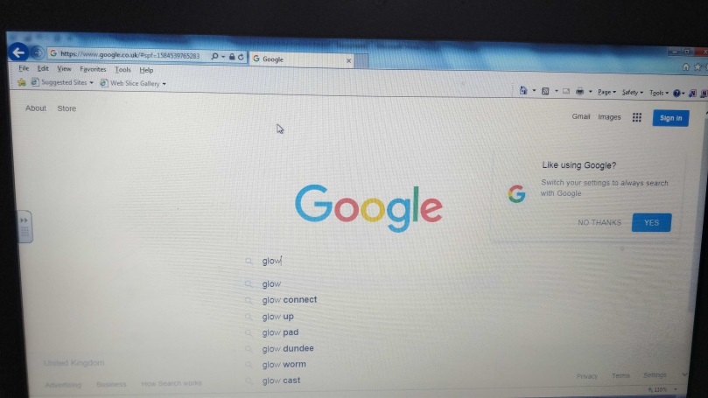
First get a device that has access to the internet e.g computer, laptop, tablet and parent’s mobile. Then go on to Google and search glow.

Step 2
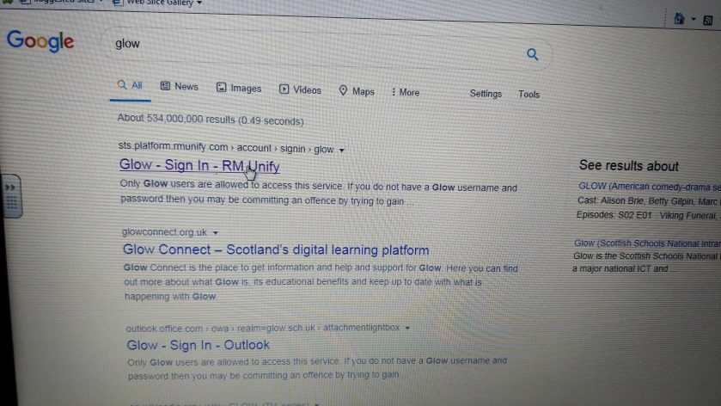
After that click on ‘Glow-Sign In-RM Unify’ and it will take you to the glow log on page.

Step 3
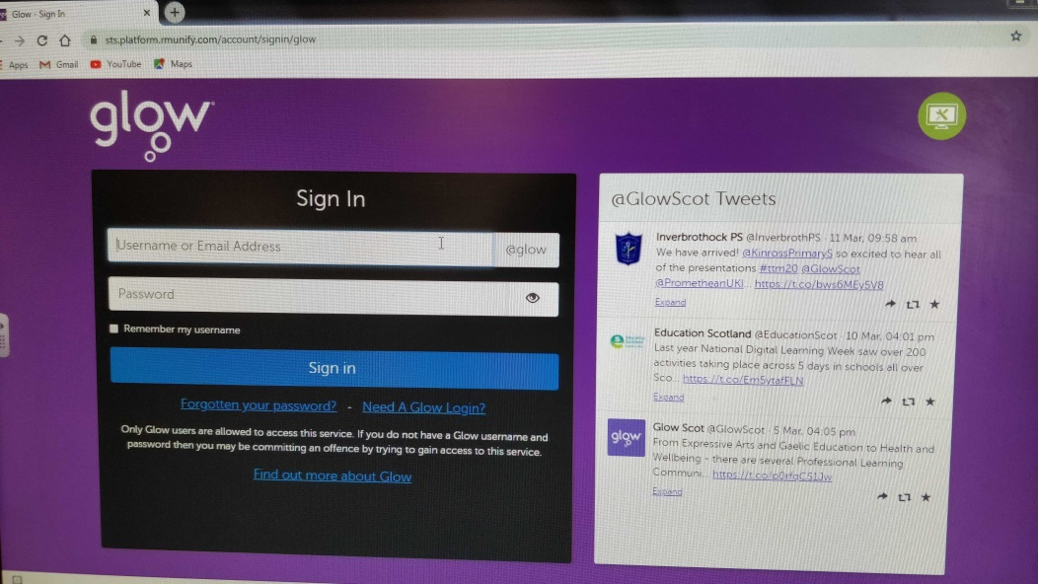
You will then input your glow email and password given by the school.

Step 4
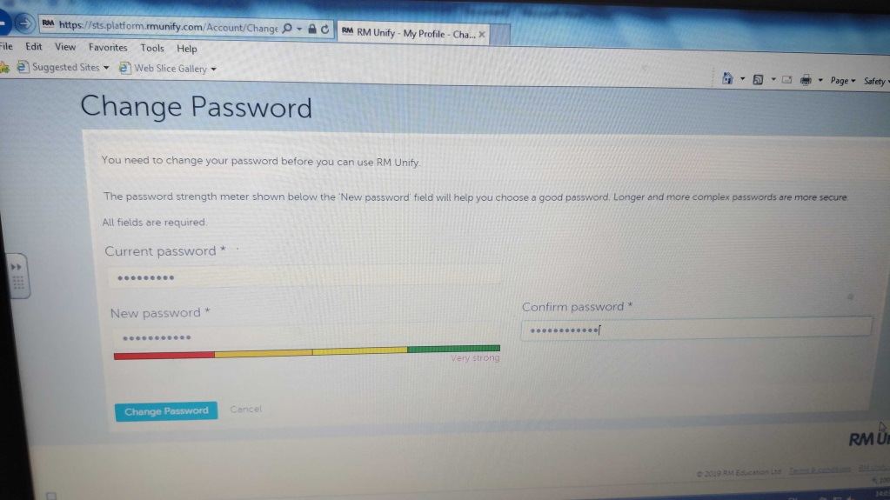
It will then ask you to change your password, so you will then need to input your current password and a new password. Make sure that the new password that you choose is strong or very strong.

Step 5
It will then alert you that it has been ‘successfully updated’. After that you will need to close the tab and then again follow Step 1 and Step 2. Once on the glow log on page you will use your email and new password to log on.
