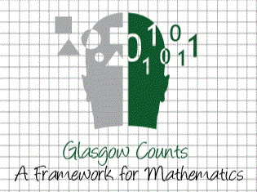 **Home Learning Wall – Numeracy **

**Six times table chain game**

Draw a long rectangle with 10 boxes.

Pick a number can (between 1-10), e.g. 3 and write the third multiple of 6 in the third box. Keep going until you have all the multiples of 6.

Draw a long rectangle with 10 boxes

Pick a number card(between 1-10) eg You pick a 3. Write the multiple of 5 in the third box. Keep going until you have all the multiples of 5.

**What’s the question?**

**Roll a dice 3 times to create a 3 digit number. How many sums, word problems and questions can you think of to match your number? Record in a mind map.**

**Make a Poster**

Design a poster to demonstrate your understanding of 14x7! It should include at least 3 facts.

**What else do you know?**

**If you know 8X4 is 32….what else can you work out?**

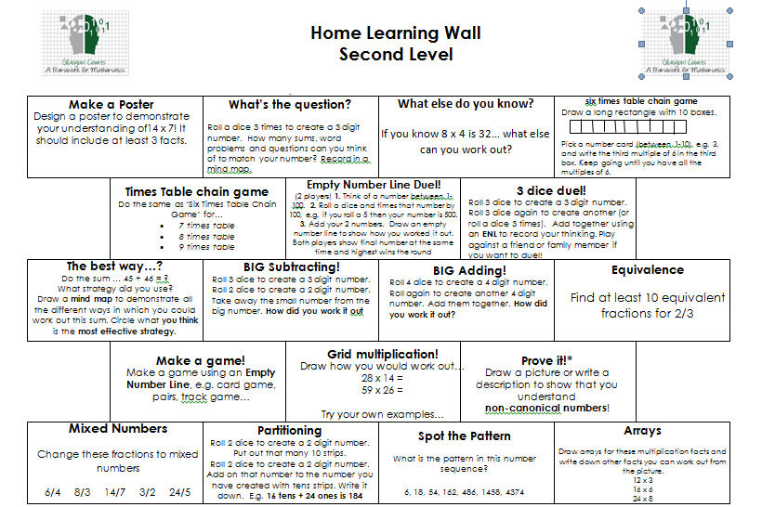

**The best way…?**

Do the sum….45+ 46=?

What strategy did you use?

Draw a mind map to demonstrate all the different ways in which you could work out this sum. Circle what you think is the most effective strategy.

**Empty Number Line**

(2 player) 1. Think of a number between 1-100.2.Roll a dice and times that number by 100,e.g. if you roll a 5 then your number is 500.3. Add your 2 numbers. Draw an empty number line to show how you worked it out. Both players show final number at the same time and highest wins the round

**Partitioning**

Roll 2 dice to create a 2 digit number. Put out that many 10 strips. Roll 2 dice to create a 2 digit number. Add on that number to the number you have created with tens strips. Write it down. E.g. 16 tens + 24 ones is 184 2Draw how you would work out…

1.5x4=

2.5x6=

Try your own example….

**STEM**

Design and construct a bridge that can support the weight of a book using everyday objects in your house

**Spot the Pattern**

**What is the pattern in this number sequences?**

**6,18,54,162,…..**

**BIG Adding!**

Roll 4 dice to create a 4 digit number. Roll again to create another 4 digit number. Add them together. How did you work it out?

These activities are a mix of practical tasks being taught and covered in class, and more challenging maths concepts to push pupils independently. **Tick each task when it has been completed.** Tasks can be done more than once. **Good luck!**

**Mixed Numbers**

**Change these fractions to mixed numbers**

**6/4 8/3 14/7 3/2 partitioning, or something else** dice. Add 10. How many now?

**Prove it!**

**Draw a picture or write a description to show that you understand**

**Of how to partition numbers!**

**Grid Multiplication!**

Draw how you would work out…

28x14=

59x26=

Try your own examples

**Make a game!**

**Make a game using an Empty Number Line, e.g. card game, pairs, track game……….**

**Equivalence**

Find at least 10 equivalent fractions for 2/3

**BIG Subtracting!**

Roll 3 dice to create a 3 digit number.

Rioll 2 dice to create a 2 digit number. Take away the small number from the big number. How did you work it out?

**3 dice duel!**

Roll 3 dice to create a 3 digit number. Roll 3 dice again to create another (or roll a dice 3 times). Add together using a strategy of your choice.

**Times table chain game**

Do the same as the “Six times table chain game” for….

• 7 times table • 9 times table

• 8 times table

**Dice tens**

Roll the dice. Add 10. How many now?

Play against someone and try and beat